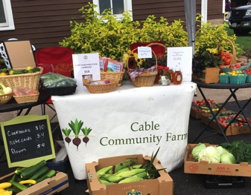

2019
annual report

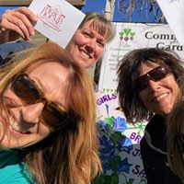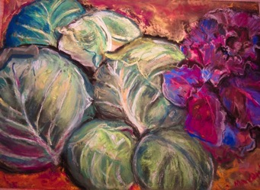

mission: grow food, build community

The vision of the Cable Community Farm is that our community has abundant access to affordable, healthy food and that our farm is a hub for learning and growing. We value sustainability, inclusivity, and collaboration.

Cable Community Farm
13765 Perry Lake Road
Cable, WI 54821

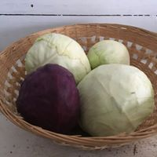 | 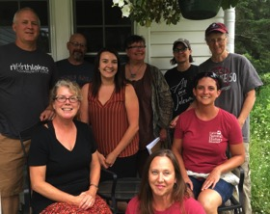
letter from the executive director

Our mission is simple: to grow food and build community. Because of you, our organization is growing more food for the community than ever before! Volunteers in the Growing Together Garden grew so much produce that we were able to have a strong season at the Cable Farmers Market, with twenty-five different varieties of vegetables and four different kinds of fruit. This kind of growth and diversity is not only good for a healthy diet, but also leads to greater biodiversity in the gardens and increased sustainability for our organization. We are grateful for the volunteers who tended the gardens and to those who purchased fresh, organic produce this summer!  Project Leaders, who take care of the Community Garden, the Growing Together Garden, the Community Chicken Coop, and Community Apiary, are highlighted in bold green throughout this report. | Our talented and dedicated Board of Directors was asked to offer words that relate to our mission and vision. These words, highlighted in bold purple, reflect our values and their impact.  The 2019 Vegetable of the Year was the cabbage! Thanks to our Local Business Heroes, we distributed over 1,000 packets of cabbage seed, along with planting instructions, throughout the community, demonstrating that it’s fun and easy to grow some of your food!  In 2020, we look forward to developing new partnerships to broaden our impact within the community so that everybody can have access to healthy food.  With gratitude,  Katie Hancock

2019 board of directors Katie Hancock, Candis Hankins, Mollie Kreb, Kristine Lendved, Sarah Letke, Monte Lewis, Emily Stone, Leslie Strapon, and Dodson Thompson

growing food

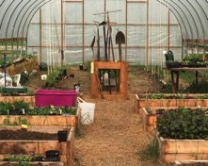 | 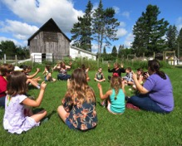 | 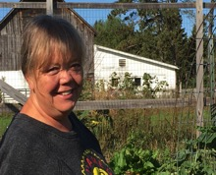
Growing  Community Gardeners tended 42 garden plots between the Community Garden, the Hoop House, and the Downtown Garden. That’s a lot of locally-produced fresh, organic produce going straight from the earth to kitchens in our community. Special thanks to Jim and Kathy Teasdale, the Project Leaders for the Community Garden The garden plots were full of flowers to attract pollinators and provide beauty. Thanks to all of the volunteers who mowed the paths in the Community Garden, repaired lawn mowers, and filled the compost bins! | Learning  The Cable Natural History Museum’s Junior Naturalist program offers environmental education for children. When they visit the Cable Community Farm, they learn about how growing food in a sustainable manner is good for people and for the environment. Our shared summer intern, Norveig Olson, was passionate about limiting the spread of invasive species and held “invasive species bonfires” at the farm this past summer to share information about the progress being made in this area. And thanks to our beekeepers, Monte and Kay Lewis, for sharing your knowledge about pollinators with our community. | Sharing  Volunteers in the Growing Together Garden planted, weeded, and harvested over 2,400 pounds of produce, most of which was donated to the Cable Area Food Shelf and Free Food Mondays. Thanks, Liz Schneller, for your care and leadership in the Growing Together Garden. Pears harvested from the Community Orchard were donated to the Velo Café, where they were made into ginger pear scones and a bumper crop of parsnips led to roasted parsnip soup on the menu at the Brick House Café!

building community
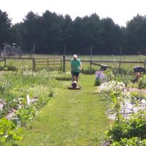 | Volunteers  Volunteers worked in the Growing Together Garden, delivered produce to the Cable Area Food Shelf, and planted the Vegetable of the Year garden. Volunteers also mowed paths, painted buildings, planted trees, and mended fences. We are so grateful for the many hands that lighten the load and the friendships that are made along the way.
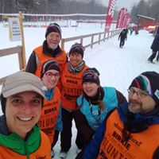 | Community Partners  Local Business Heroes support the Vegetable of the Year program, making it possible to give away 1,000 packets of cabbage seed at the Drummond Schools and throughout the community! We work to foster healthy, active lifestyles by partnering Chequamegon Area Mountain Bike Association and the American Birkebeiner Ski Foundation.
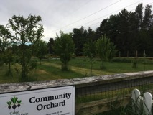 | Community Projects  Fifteen new apple trees were planted in the Community Orchard. The Community Seed Starting project allowed community members to get seeds started early with the help of grow lights and heated mats. Six households enjoyed eggs from the Community Chicken Coop, thanks to Lisa Dunleavy and Liz Schneller, Project Leaders.
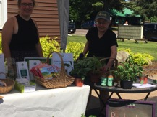 | Community Events  We participated in the Cable Farmers Market, selling extra produce from the Growing Together Garden, honey from the Community Apiary, and our “Farm to Table” cookbooks. We recycled a lot of stuff in the Community Garage Sale! We presented the “Turnip Award” at our 7th annual Harvest Dinner in October.

financial reports
support and revenue:
total: $19,848

expenses:

Thank you for supporting our mission in 2019:
thank you
Kent and Elaine Adams
Mary Ann Allen
Ron and Patty Anderson
Beth and TJ Barnes
Sara Balbin and Gary Crandall
Beverly Bauer
Jeanne Baxter
Judith Benedict
Ron and Kathy Bergin
Thank you to the following organizations for providing financial support for our programming:

Wisconsin Farmers Union
American Birkebeiner Ski Foundation
Ascension Episcopal Church
Namakagon Community Club
Cable UCC Women’s Fellowship

Pat and Sue Quinn Recreation Fund of the Eau Claire Community Foundation

Jan and Irv Berlin
Sarah Boles
Shirley Byrd
Jim and Sonia Casey
Joanne Cleary
Kristin Dahl
Cynthia Daube
Lisa Dunleavy
Mark and Shari Eggleson
Rich and Carol Elliker
Vikki and Tony Erba
Richard Erickson
Thank you to the following organizations for providing financial support for our programming:

Wisconsin Farmers Union

Pat and Sue Quinn Recreation Fund of the Eau Claire Community Foundation

American Birkebeiner Ski Foundation

United Healthcare

Margaret Flowers
Eileen Furlong
Katie and Art Hancock
Susan Hand
Vivianne Hanke
Thank you our 2019 Local Business Heroes:

Arm & Hammer Builders
Brick House Café
Cable Chiropractic
Cable Lumber & Home
Cable Natural History Museum
Chequamegon MTB Festival
King Realty
Mark Rasmussen Excavating
My Villa Home Décor
Northern Native Plantscapes
Northland Lawn & Sport
Norvado
Parker Electric
Redbery Books
Rondeau’s Shopping Center
Start Line Inn
Velo Café

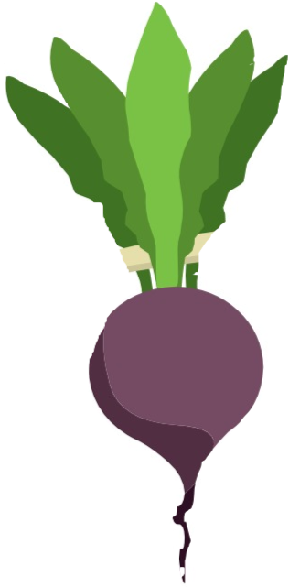

Larry and Teri Hanson
Holly Hart
Ed and Adrian Hilz
Wendy Hitch
Elizabeth Holland
Ed Johnston
Clarence Karrow
Dale Kruse
Jackie Kruse
Dorothy Lagerroos
Barb Larson
Ruth Lauritzen
Kristine Lendved
Monte and Kay Lewis
Deb and Carl Lippert
Cathy Midwood
Kari and Norm Nitzkowski
Jon and Susan Nymo
Carolyn and Ralph Owen
Roberto Palombi
Arlyn Posekany
Bruce and Sara Qualey
Pat and Sue Quinn
Sue Rosa
Rose Rothstein
Liz Schneller
George and Cindy Siebolt
Emily Stone
Leslie Strapon
Kim Stuber
Jim and Kathy Teasdale
Cable Community Farm
13765 Perry Lake Road, Cable, WI 54821 www.cablecommunityfarm.org

Kris and D Thompson
Kelli Tuttle
John and Kathy Uffenbeck
Anita Warren
Dale Watterson
Mary and Jack Wichita
Ned and Kathy Zuelsdorff

