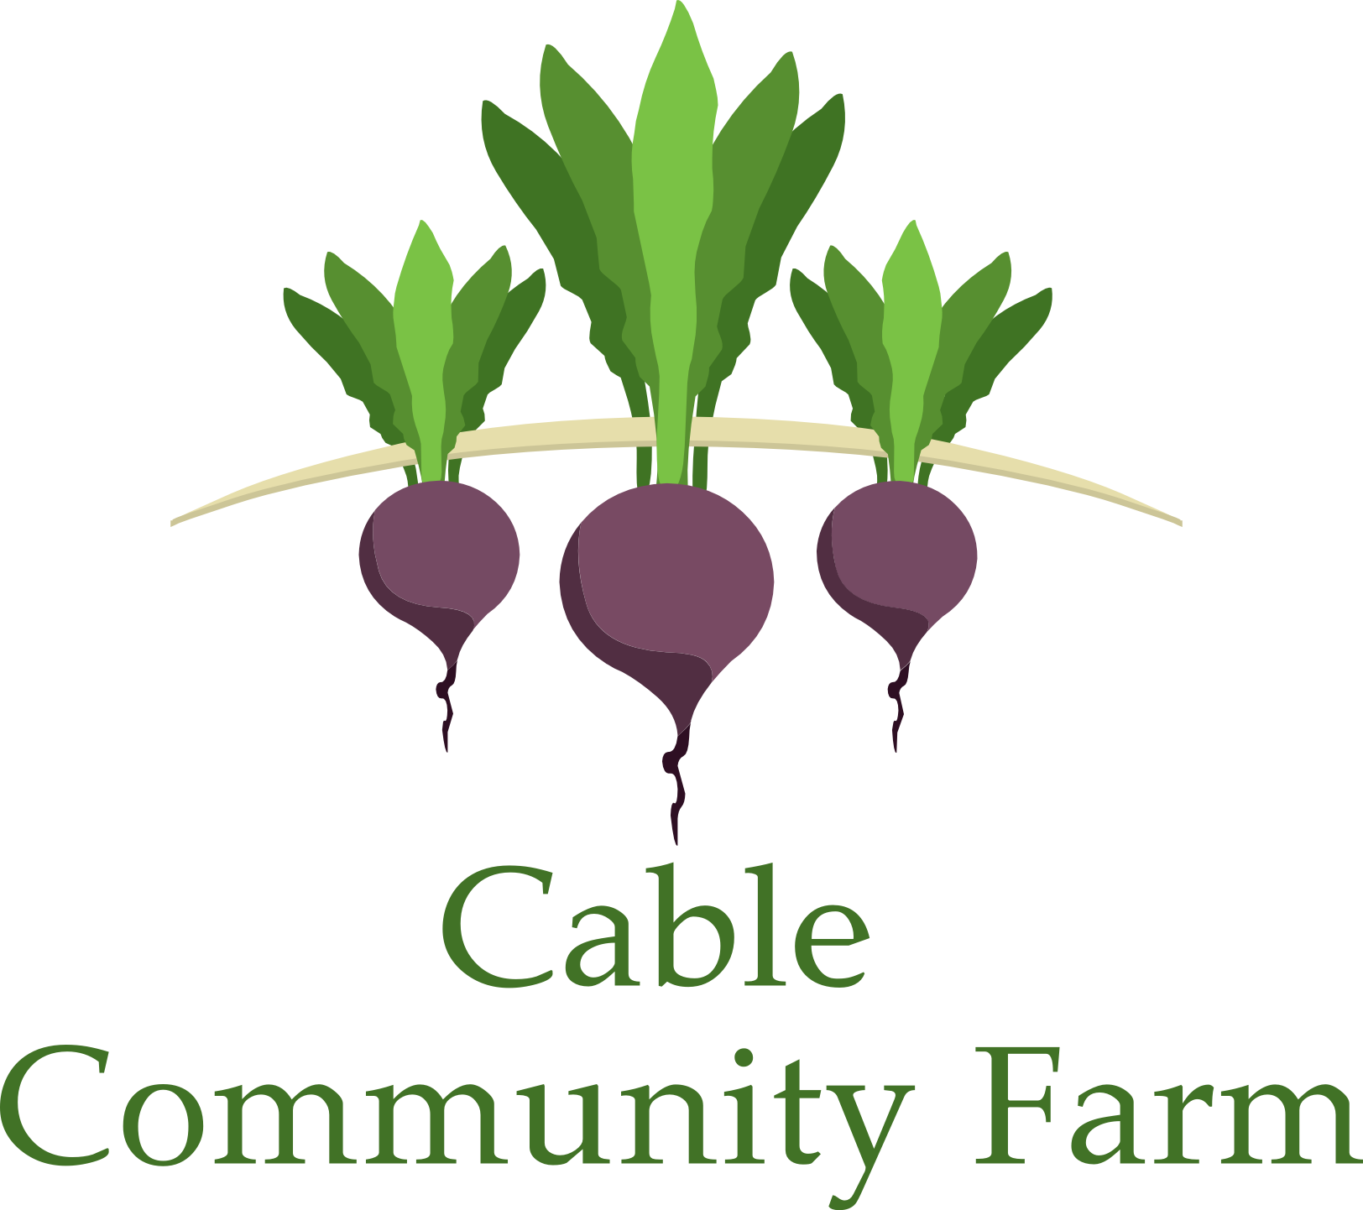

2016
Sunday Afternoons at the Farm
13765 Perry Lake Road

Backyard Farming
Sundays 3:00 pm

Mini-workshops open to the public and appropriate for all ages and experience levels.
Free of charge. Snacks provided.

6/5 Planting Pumpkin Seedlings with Katie Hancock
6/12 Planting Fruit Trees with Kelli Tuttle
6/19 Beekeeping with Monte Lewis
6/26 Nature’s Garden Trail with Yulia Welk
7/3 Pastured Poultry: Cornish X Broilers and Pekin Ducks with Farmer Aaron
7/10 Pastured Poultry: Community Coop and mobile hen house with Farmer Aaron
7/17 Community Vineyard with Tom Nigbor
7/24 Let’s Make Hay: Scything with Adrian Wydeven
7/31 Plein Air Garden Painting with Mimi Crandall
8/7 Native Plant Identification with Sarah Boles
8/14 Composting with Katie Hancock
8/21 Nature’s Garden Trail with Emily Stone
8/28 Vegetable of the Year: Let’s make Dilly Beans!

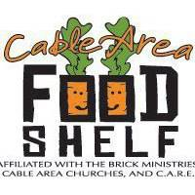 | Growing Together Garden  Sundays 4 – 6 pm  Come help us tend the Growing Together Garden, where we grow food for the Cable Area Food Shelf and Free Food Mondays. Take some fresh produce home during the harvest season.

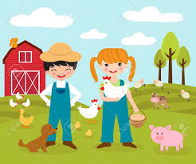 | Little Farmers  Sundays 3 – 6 pm  A place for parents and their young children to play and learn about farming. Features include a children’s garden, pedal tractors, a green bean planting station, and a reading stage in the old barn.

Thanks to Xcel Energy for funding Backyard Farming!


