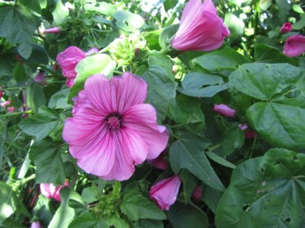
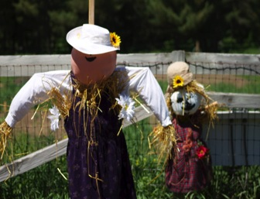
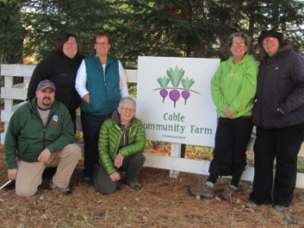
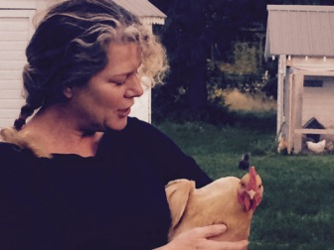
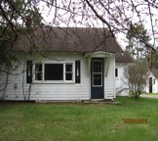
mission: grow food build community

The vision of the Cable Community Farm is that we will be a hub for learning and growing and that our community will have abundant access to affordable, healthy food. We value sustainability, inclusivity, and collaboration.

+

2014

annual report
+

2014 board of directors
Aaron Campbell, Holly Hart, Kristine Lendved, Caroline Perkins, Rose Rothstein, Emily Stone, Susan Thurn, and Kelli Tuttle

Healthy food is good for people, good for our community, and good for the earth. As the executive director for the Cable Community Farm, I am so fortunate to work within a community that embraces local food, not only because it tastes great, but because it reduces the impact that we have on the planet. It is our contention that if we can provide garden space and teach people how to grow some of their own food, our community will be stronger and healthier.
2014 has been an exciting year for our organization. In August, we received our letter of determination from the Internal Revenue Service stating that we are now recognized as a 501©3 nonprofit organization. In October, we learned that we have been recognized as a Travel Green Wisconsin destination. We are proud of both of these distinctions because it means that we have joined the ranks of other organizations within our community and across the globe who are working to make the world a better place.
Our board of directors shares this dedication as they all have a passion for healthy food and for contributing to a community that shares its resources joyfully and abundantly. Please take a moment to thank them for their work when you see them in town.
With gratitude, Katie Hancock

letter from the executive director
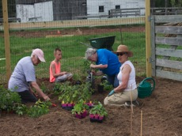
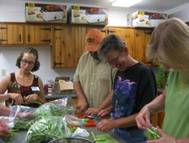
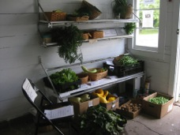
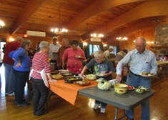
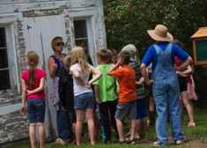
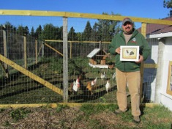
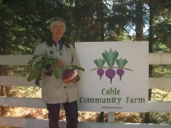
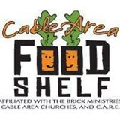
Sharing
We distributed 807 pounds of fresh, organic produce through Free Food Mondays. Fresh food was harvested every Sunday night during the growing season and placed in the “milk house” building at the Cable Community Farm. Anybody was welcome to pick up the fresh food. Survey data indicated that 88% of the respondents ate more fresh food because of Free Food Mondays and 61% tried a new kind of food.
Learning
We held 10 classes that were offered free of charge to all members of our community. The classes were attended by over 30 individuals, with most participating in more than one class. Topics ranged from “Vegetable Gardening for Beginners” to “Fruit Tree Planting” to “Water Bath Basics” and were taught by both community members and University of Wisconsin Extension staff.

Growing
The Community Garden was full of life throughout the growing season, with 25 gardeners growing food for themselves, their families, and neighbors. Through volunteer labor in the Growing Together Garden, we donated 235 pounds of fresh, organic produce to the Cable Area Food Shelf. We delivered 33 different varieties of produce, along with recipes featuring the donated produce. The Growing Together project is supported through the Community Opportunity Fund of the Duluth Superior Area Community Foundation.

growing food
Community Events
We hold a potluck-style Harvest Dinner that is open to everybody in the community. We had 18 dishes and over 50 participants. We held our first Community Halloween Party in 2014 with over 100 people who enjoyed the haunted barn, hayrides, candy, hot chocolate, and a bonfire on a very chilly night in October.
Community Projects
We planted 35 fruit trees for a Community Orchard and house 20 laying hens in a Community Chicken Coop. We grow flowers in the Theatre Flowers Garden for the Chequamegon Children’s Theater and we house the Cable Community Seed Library, in collaboration with the Forest Lodge Public Library. Community projects provide opportunities for everybody to be involved.
Collaborators
We enjoy partnering with other nonprofit organizations, such as the Cable Natural History Museum, to broaden our reach and deepen our offerings. We collaborate with busineses, such as Redbery Books and Northern Native Plantscapes, and enjoy having students from the Drummond Schools at the Cable Community Farm. We all know that it’s important to work together.
Volunteers
37 volunteers donated 292 volunteer hours to grow food in the Growing Together garden. Volunteers also delivered baskets of fresh produce to community members, participated in Work Days, baked treats for classes, built fences, planted fruit trees, painted farm buildings, and smiled through it all. In fact, most of them felt that they benefitted more themselves than the recipients of their work.
+
building community
financial reports

support and revenue:
total: $24,611

expenses:

Thank you to the following individuals who contributed to our mission by making financial contributions in 2014:
Lisa Arthur
Sara Balbin
Aaron Campbell
Anne Cogswell
Vivianne Hanke
Candy Hankins
Larry and Teri Hanson
Holly Hart
Ed Johnston
Jackie Kruse
Dorothy Lagerroos
Barb Larson
Ruth Lauritzen
Kristine Lendved
Monte and Kay Lewis
Jacque Lindskoog
Susan Nymo
Caroline and Skip Perkins
Bruce and Sara Qualey
Pat and Sue Quinn
Suzanne Rooney
Rose Rothstein
William Schulz
Wendy Jaine Summers
Emily Stone
Kelli Tuttle
Mary Wichita
Les and Amy York

thank

you
+
Thank you to the following businesses who contributed in-kind donations in 2014:
Cable Lumber and Home
John Scheeppers Seed Company
Northern Lakes Coop
High Mowing Seed Company
United Ag Feed Store
Cable Natural History Museum
Jonjak Cranberry Farm
Seed Savers Exchange
13765 Perry Lake Road
Cable, WI 54821
www.cablecommunityfarm.org
Cable Community Farm
+
Thank you to these organizations who generously contributed to our work in 2014: