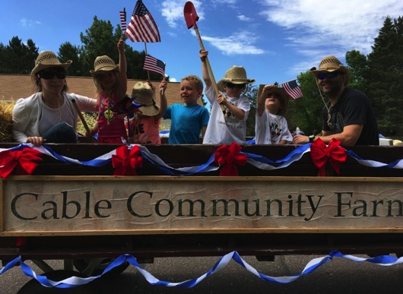

2016
annual report
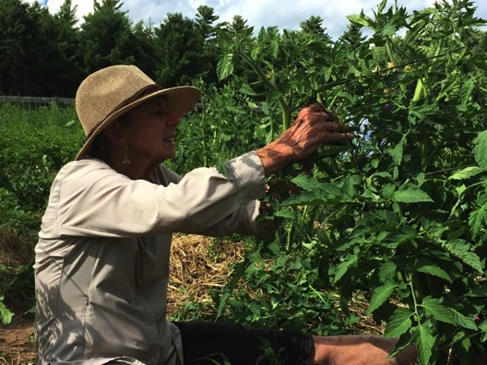
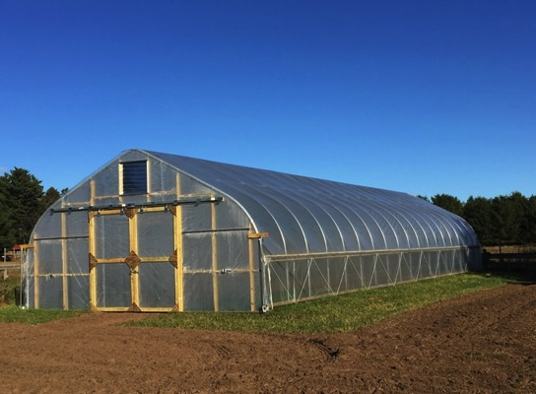

mission: grow food, build community

The vision of the Cable Community Farm is that our community has abundant access to affordable, healthy food and that our farm is a hub for learning and growing. We value sustainability, inclusivity, and collaboration.
Cable Community Farm 13765 Perry Lake Road Cable, WI 54821

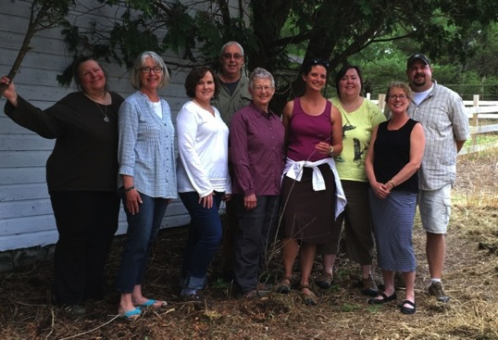
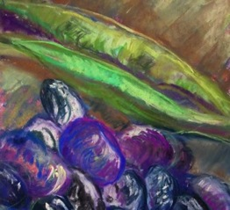
letter from the executive director

A farm is a wonderfully rich and diverse environment: flowers, vegetables, bees, insects, and animals all working together. A community farm is diverse not only in the ecological sense, but also in terms of its people. We are a group of people as diverse as any group in the northland in terms of economics and politics and personal preferences, but we are united in our belief that growing healthy food to nourish ourselves, our families, and our neighbors is very important.
The 2016 Vegetable of the Year was the bean, which is a very versatile vegetable. We grew many varieties of both bush beans and pole beans. The more we picked, the more the plants produced! We also gave away 1,000 packets of bean seeds to all of the elementary students at the
Drummond School, to our community through local businesses, and to visitors during the Fourth of July parade.
Our new (to us!) tractor was a star in the parade this year. We were able to purchase a tiller to go with it…thanks to you!
Another new feature at the farm is the Community Hoop House, which will allow us to grow produce from March through November.
We are fortunate to have such a rich and diverse ecosystem at the farm. We recognize that biodiversity is essential for growing food and that it leads to healthier communities and a healthier planet.
Cheers to 2017! Katie Hancock

2016 board of directors
Aaron Campbell, Katie Hancock, Jackie Kruse, Kristine Lendved, Metro Maznio III, Amy Nigbor, Caroline Perkins, Emily Stone, and Susan Thurn.

growing food

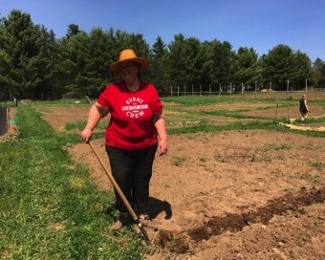
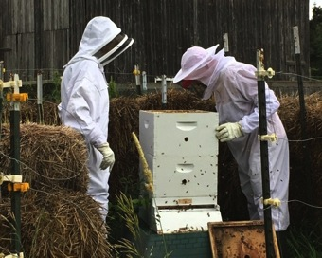
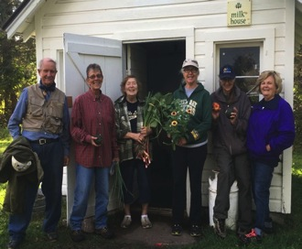

Growing
The Community Garden was full of life throughout the growing season, with 25 gardeners growing food for themselves, their families, and neighbors. The Community Garden Co-Coordinators, Cec Peterson and Elsa Hansen, did a fabulous job keeping the paths mowed, compost turned, and everybody informed.
Many gardeners planted flowers in their plots, adding a lovely splash of color (and an opportunity for pollinators to do their work) amidst all of the green!

Learning
Our Backyard Farming workshops provided opportunities for community members to share information with each other about a variety of topics, including wild edibles, making compost, raising chickens for meat and eggs, identifying native plants, growing grapes, and beekeeping.
During the tree planting workshop, volunteers planted a new row of apple trees in the Community Orchard. Thanks to a grant from Xcel Energy, we were able to offer these workshops free of charge!

Sharing
We distributed over 1,300 pounds of fresh, organic produce to the Cable Area Food Shelf and Free Food Mondays. Fresh food was harvested every Sunday afternoon during the growing season and placed in the “milk house” building at the Cable Community Farm.
Anybody was welcome to pick up the fresh food. One of our volunteers also delivered baskets of fresh food to members of our community who are unable to get out to the farm. The Community Seed Library was full of seed packets that are available free of charge.

building community

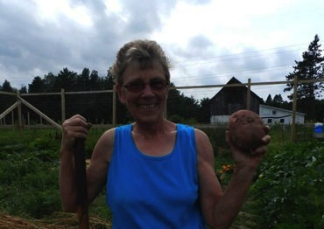
Volunteers
Since the Cable Community Farm is an all-volunteer organization, volunteers make everything we do possible! Volunteers worked in the Growing Together Garden, participated in Work Days, baked treats for classes, built fences, painted farm buildings, and smiled through it all. We are so grateful for the many hands that lighten the load!

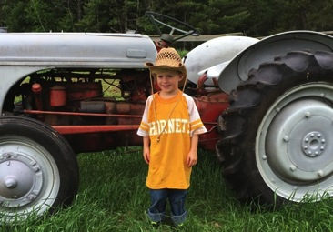
Collaborators

We enjoyed partnering with other nonprofit organizations, such as the Cable Natural History Museum, to broaden our reach and deepen our offerings. We enjoyed having Redbery Storytime at the Cable Community Farm, where the children enjoyed listening to stories about farming and playing in the Little Farmers play area.

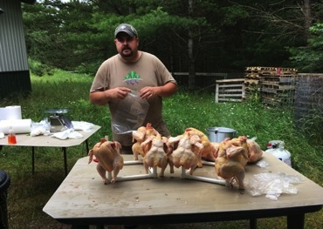
Community Projects
Farmer Aaron raised 120 Cornish X broiler chickens (and 40 Pekin ducks) at the farm. On butchering day, those who were purchasing chickens were invited to help with the processing. Thanks to the Wisconsin Farmers Union for supporting this project! The Community Chicken Coop provided eggs for the “Chicken Tenders” and also for egg sales to the community!

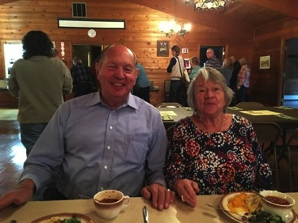
Community Events
We participated in the Cable Farmers Market, selling rhubarb, pea shoots, and flowers from the Theatre Flowers Garden. Every year, we host a potluck-style Harvest Dinner at the Cable Community Center that is open to everybody in the community. This year’s dinner was well-attended with lots of laughter, green beans, and piano accompaniment.

financial reports
support and revenue: total: $26,170
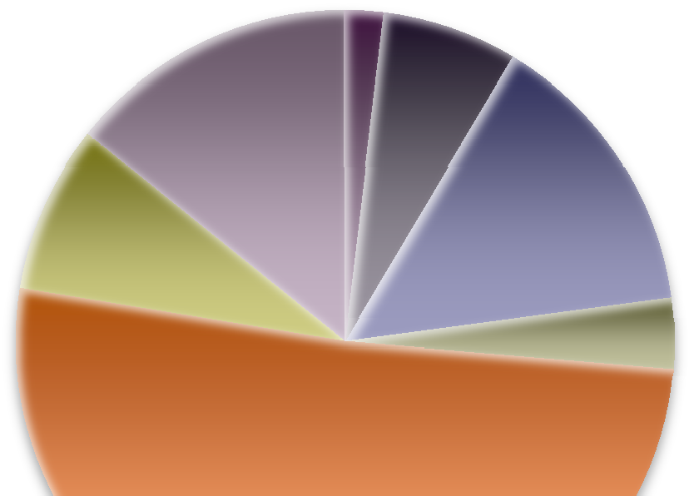

Corporations Foundations Government Grants Local Business Heroes Donations
Programs and Events Sales

expenses:

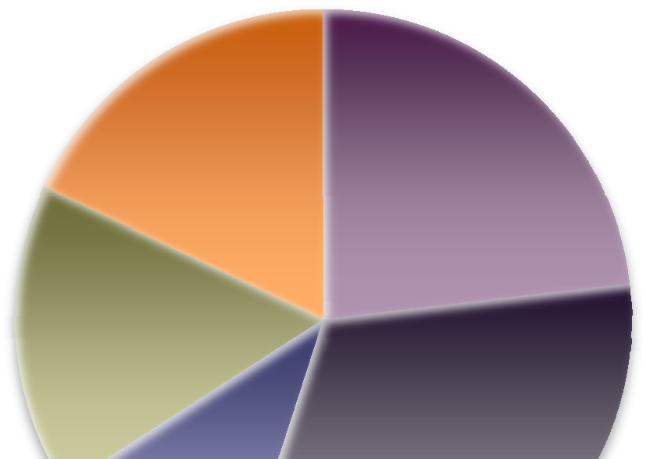

Programs and Events Operational Costs Capital Development Pumpkin Project Poultry Projects

Thank you for contributing to our mission in 2016:
thank you
Ron and Patty Anderson

Jeanne Baxter
Jan and Irv Berlin Sarah Boles
Joanne Cleary

Mimi Crandall

Caroline Fiala
Jeff Gajdos Vivianne Hanke Candy Hankins
Thank you to the following organizations for providing financial support for our programming:

Wisconsin Farmers Union SeedMoney
Agate Woods Education USDA EQUIP Program
Pat and Sue Quinn Recreation Fund of the Eau Claire Community Foundation American Birkebeiner Ski Foundation
Larry and Teri Hanson Holly Hart
Wendy Hitch
Marlene and Richard Hogue Pamala Jacobel
Ed Johnston Jackie Kruse
Dorothy Lagerroos
Barb Larson Ruth Lauritzen
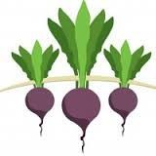Kristine Lendved Sarah and Tom Letke Monte and Kay Lewis Jacque Lindskoog Peter Marshall
Thank you to our Local Business Heroes!
Brick House Cafe Cable Chiropractic
Cable Natural History Museum Chequamegon Fat Tire Festuval CrossWoods Camp
Cable Lumber and Home King Realty
Northern Native Plantscapes Northland Sport and Equipment Redbery Books
Rondeau’s Shopping Center Sara Qualey Studios
Xcel Energy
Metro Maznio III Colleen McIntyre Tom and Amy Nigbor
Norman and Kari Nitzkowsi
Jon and Susan Nymo William Oslund
Carolyn and Ralph Owen Roberto Palombi
Cecelia Peterson Caroline and Skip Perkins Kelly Plote
Extra Special Thanks: Richard Erickson
Art and Char Hancock
Farmer Aaron Campbell
Bruce and Sara Qualey
Pat and Sue Quinn
Mark and Kathy Rasmussen Suzanne Rooney
Rose Rothstein Emily Stone
Kris and D Thompson Sue Thurn
Anita Warren Jean Weisz
Cable Community Farm

13765 Perry Lake Road Cable, WI 54821
Wendy Wethington
Mary Wichita
Sarah and Brad Wilkinson Colette Wolf
Les and Amy York

