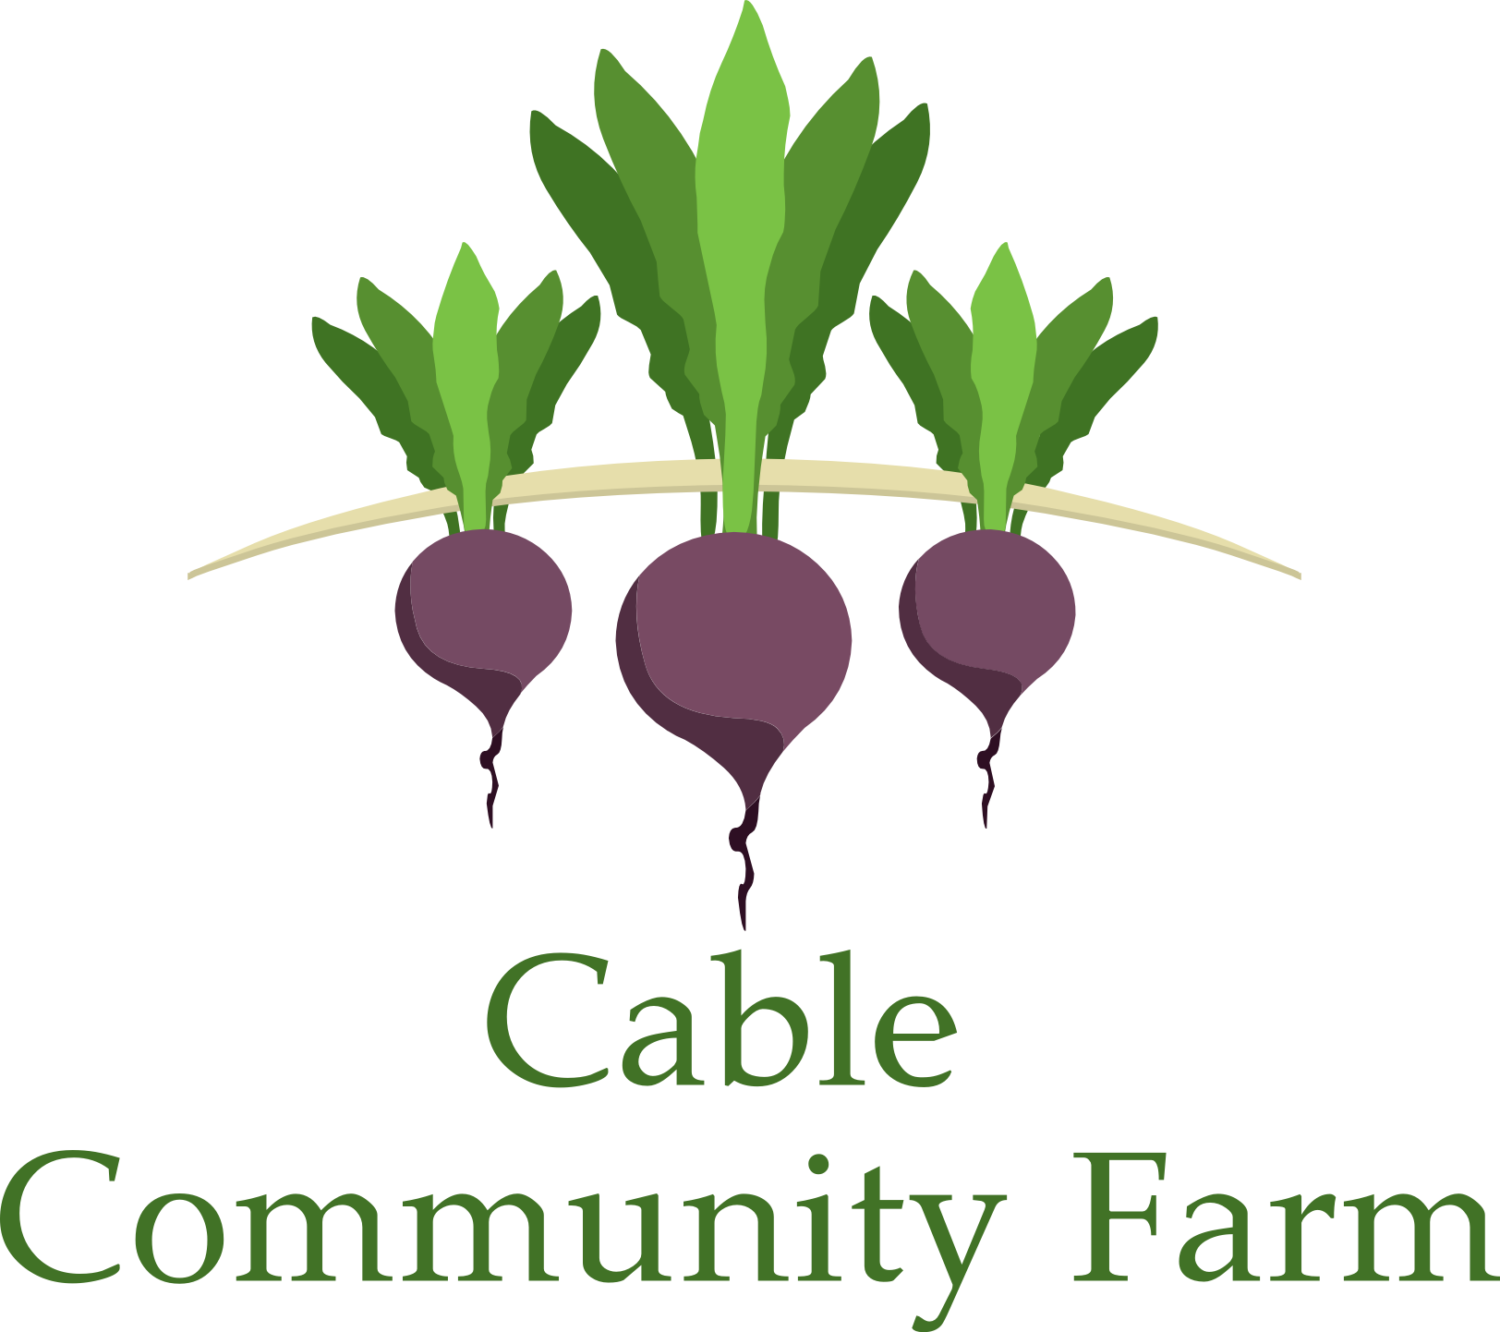 | mission: grow food, build community

Friends of the Farm

Friends of the Farm support the mission of the Cable Community Farm by making financial contributions. Contributions are used for operational costs, programming, and development.
Friends of the Farm receive the following benefits: monthly e-newsletter, annual e-report, invitations to programs, workshops, classes, and events held at the Cable Community Farm, and the good feeling that comes from knowing you helped a community project get off to a good start.

Name ____________________________________________________

Address _____________________________________________________

_____________________________________________________

Phone _____________________________________________________

Email _____________________________________________________

______ check here if you would prefer to receive news through the mail.

In addition to your financial support, would you like to be a volunteer?
Volunteers will be needed to run events and programs, participate in “work days”, and complete other tasks that come up from time to time. Volunteers will be placed on a list and called upon when needed. No special skills are necessary; however, special skills are very much appreciated.

_____Yes, I’d be happy to volunteer at the Cable Community Farm.

_____No, I’d prefer to contribute financially and pitch in when I can.

What special skills do you have? (check all that apply)

_________ Carpentry _________ Fence building _________ Event planning _________ Office Work

_________ Gardening _________ Teaching __________ Writing _________Fundraising

_________ Livestock __________ Technical Support __________ Program Development

Other (explain) ________________________________________________________

Friend of the Farm, Individual or Family $25
Friend of the Farm, Business $100
Sponsorship* $25
Other donation ______
*Your sponsorship will enable someone with limited resources to become a Friend of the Farm

Total Donation _____________

Please send this form and your check (made payable to Cable Community Farm) to 13765 Perry Lake Road, Cable, WI 54821.

Thank you! Your donation will help the Cable Community Farm grow food and build community!
For more information, visit www.cablecommunityfarm.org

